Assignment

What is Linux?
Linux is an open-source operating system that controls computer hardware and resources
GUI: Graphical user Interface
Windows operating system having GUI
CLI: command line Interface
Why Linux?
1.multiple users can login
2.open-source
3.it’s more secure than windows o.s

Linux have different distributions
Ubuntu
RHEL
Amazon Linux
SUSE

Kernels:
Linux kernel is the core, foundational software of a Linux O.S . It act like bridge between your computer physical hardware (RAM, CPU,DISK) and software application running on it.

Terminals:
Terminal are text base interface that allow you to interact with O.S by typing text commands.
Shell:
Shell is a program which takes input and gives outputs.
Command:
echo 0 is help us to get the detailed of current shell we are using.
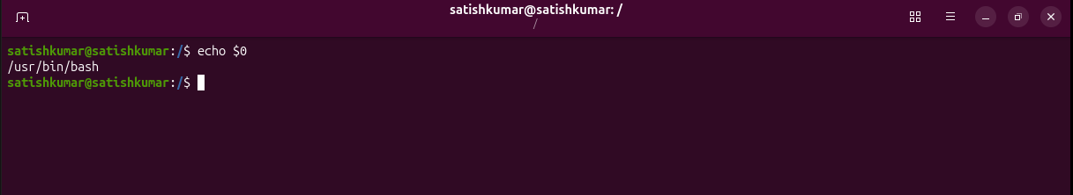

/ (forward slash): Root directory
Forward slash Represents Root directory and purpose of root directory is that contains all system files, device and user details in unified hierarchy.
A root directory is a top-level hierarchy.
Below root directory we have different directories

~ (Tild) Home directory:
~ represent the Home Directory, in operating system every user has one home directory home directory is a dedicated storage space.
pwd :
present working directory
if want to know your present directory you can use pwd.

cd :
if want to move one directory to other directory we use cd command.
cd ..
It will help us to go one step back
cd ../..
it will help us to go 2 steps back.

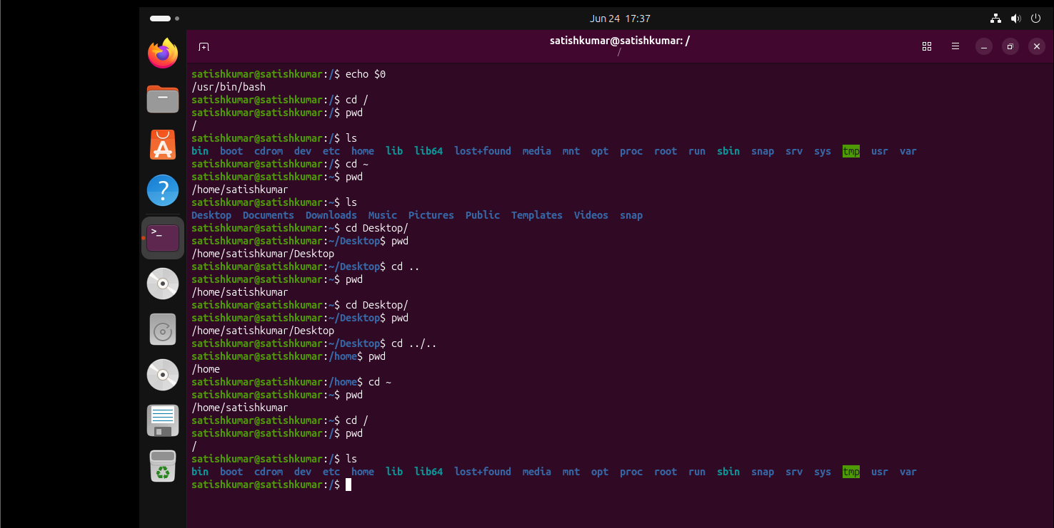
ls : list
it will help us to get list of files

ll : long list
it will help us to get complete details of our file system.
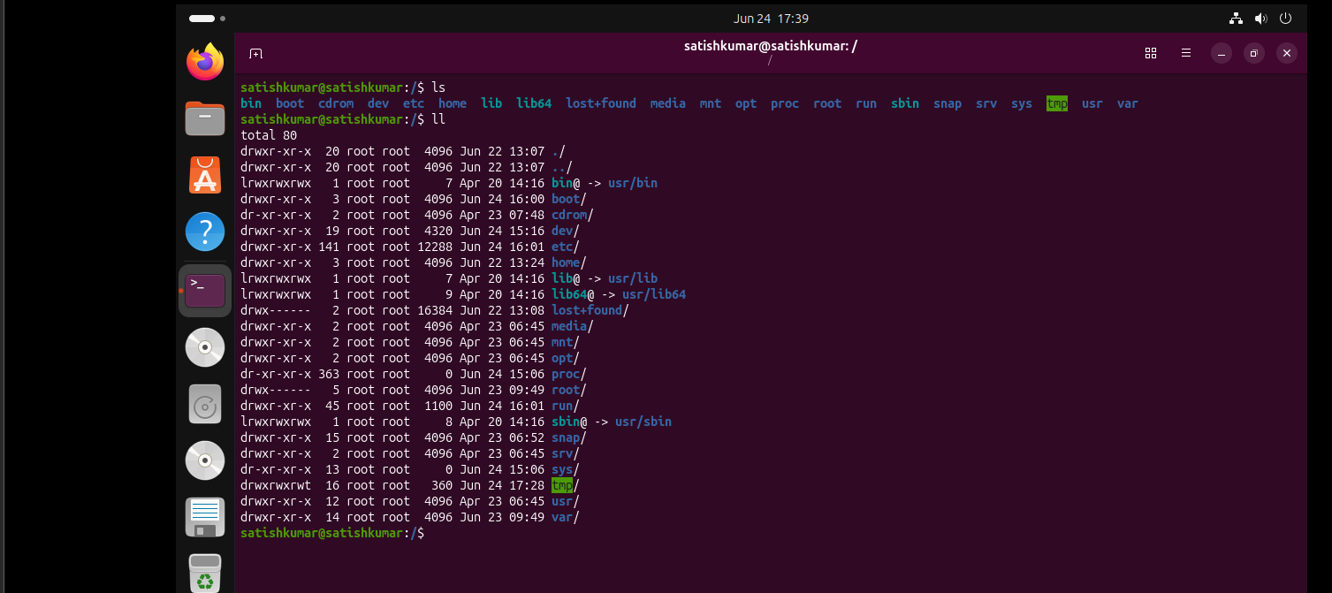

Ls-lrt : ll and ls – ltr are same
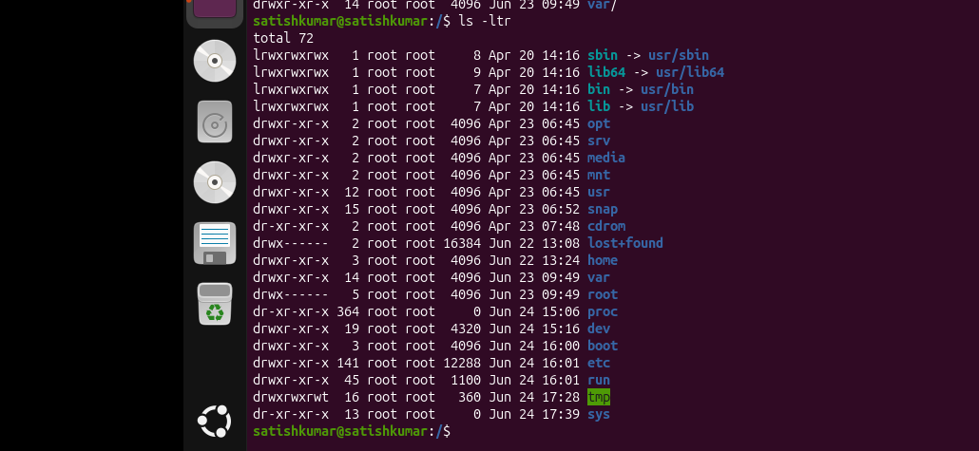
Ls-a
This command help us to get list of hidden files.
mkdir :
this command help us to create directory
a command-line utility used to create new folders within a file system
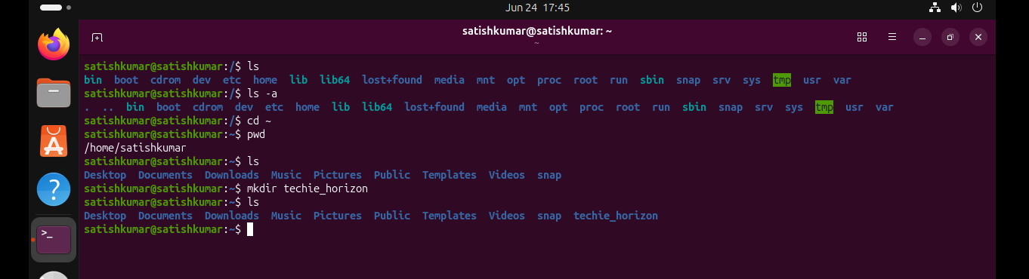
mv :
mv command is use to hide directory and also it help us to rename the file.
Command : mv directoryname. Filename
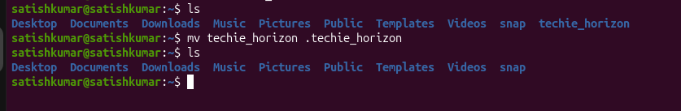
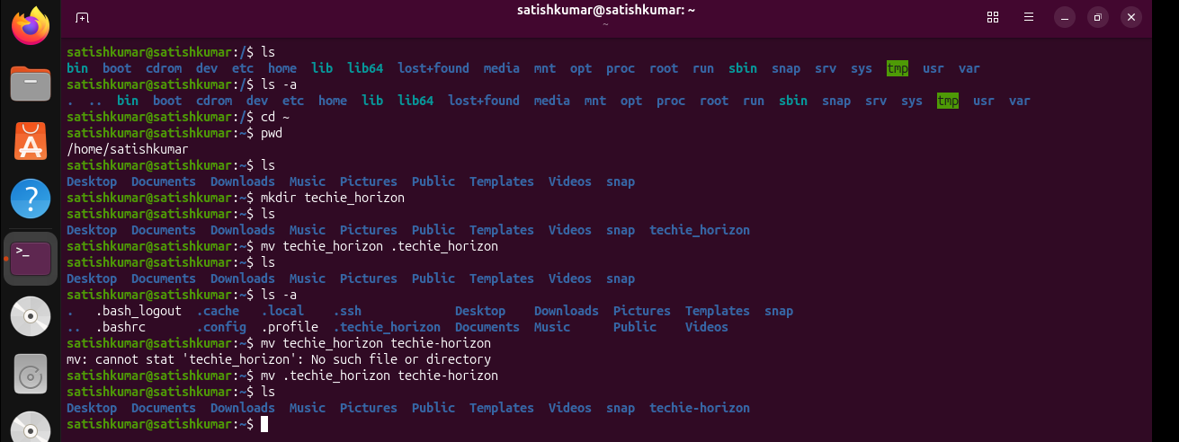
Clear : this command help us to clear the screen.
History : if want to see history we use this.
Date : if want to see date.

rm-rf : this is the command we us for delete files.
mv : mv we use this command to move file like copy and paste
cp : copy file.
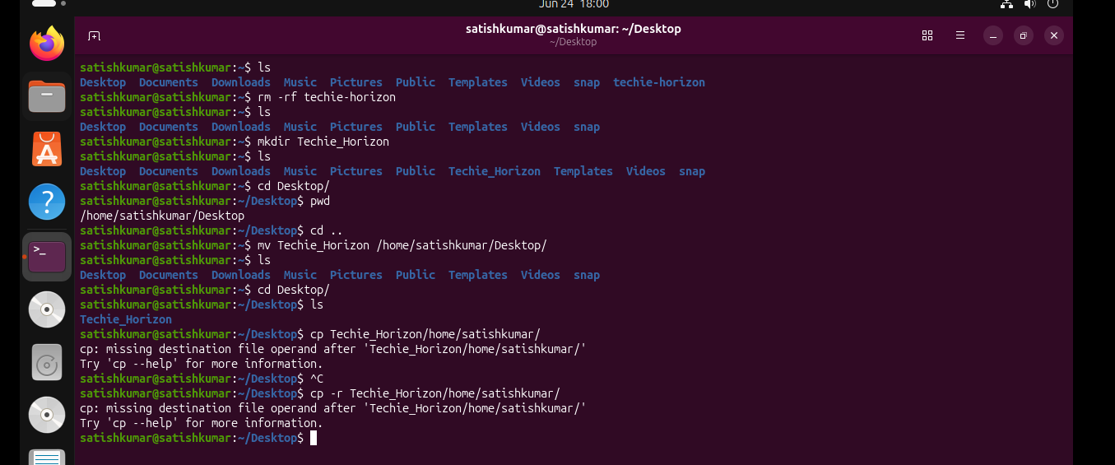
Files:
touch : this command is use to create file.

We have 3 types of editors
1.VI
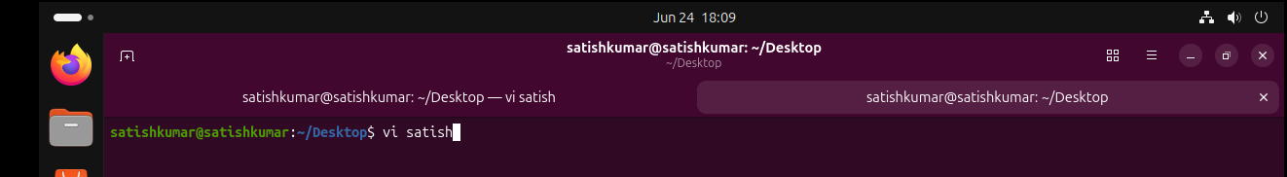

Real file
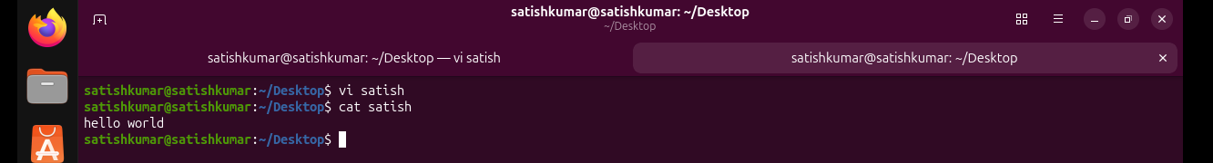
2.VIM
3.NANO
Touch with 0 size
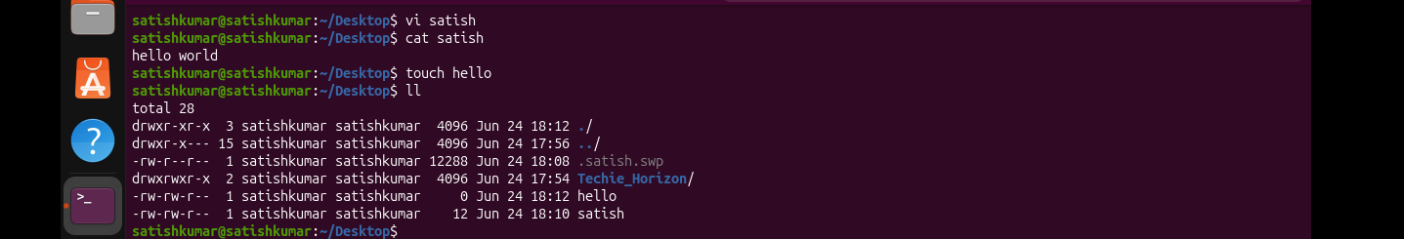

Remove file
